Part 1

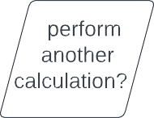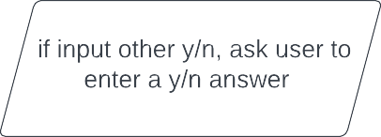

Part 2

while True:

#taking user input for name

name = input("employee name:")

#taking user input for hours you worked

name = input("employee name:")

#taking user input for hourly rate..

hourly rate = float(input("Enter hourly rate(in $): "))

#finding pay using given formula..

pay = hours worked\*hourly rate

#prinitng output..

print("\n\*\*\*\*\*\*output\*\*\*\*\*\*\n")

print("name: ",name,"\nhourly rate: ",hourly rate,"\nhours worked:

",hours worked,"\npay : $",pay)

Input: two float values

Output: three float values

1. Insert rate
2. Insert hrsworked
3. Calculate pay:rate\*hrsworked
4. Print pay
5. Ask user if they wish

To perform another calculation

Y, go back to step 1

N, exit the program

O, if user did not input y/n, we will ask the user, until we receive a y/n answer